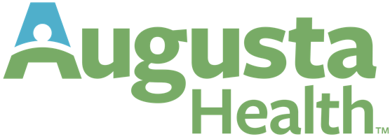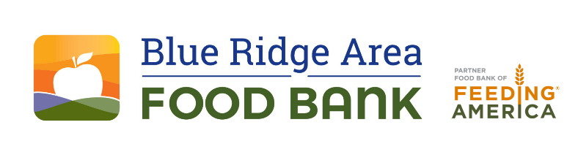

FOR IMMEDIATE RELEASE  October 23, 2024 | Media Contact: Les Sinclair  434-962-5403  lsinclair@brafb.org  www.brafb.org

Elected Officials Visit The Augusta Health Food Pantry, a Food Pharmacy Location of Blue Ridge Area Food Bank
Fishersville, VA – Oct. 23, 2024 – State leaders, including Delegate Ellen Campbell and Senator Creigh Deeds, visited The Augusta Health Food Pantry, a Food Pharmacy location of the Blue Ridge Area Food Bank, to see how partnerships between healthcare providers and food banks can improve health outcomes by increasing access to nutritious food.
The Food Pharmacy, a collaboration between Augusta Health and the Blue Ridge Area Food Bank, addresses food insecurity, a key social determinant of health. During the tour, officials discussed the program's impact and explored future expansion.
"Elected officials play a critical role in supporting policies that strengthen food security and health equity," said Clint Merritt, MD, CPE of Augusta Health. “Through our partnership with the Blue Ridge Area Food Bank, we enable our patients, employees, and communities to choose healthier food options and access nutrient-rich foods more easily."
"We're ensuring food insecurity is recognized and treated as a public health issue," added Michael McKee, CEO of Blue Ridge Area Food Bank. "This partnership is making a real difference for families across the region."
Launched in 2021, the The Augusta Health Food Pantry, a Food Pharmacy location of the Blue Ridge Area Food Bank, provides patients with medically tailored food through referrals from healthcare providers, helping them prevent and better manage chronic conditions like diabetes and heart disease. Additionally, Augusta Health’s Food Pantry obtains most of its fresh produce from the Farm at Augusta Health.
The visit underscored the need for policy support to bridge healthcare and food access, fostering healthier communities across Virginia.
Media resources are located here: https://1drv.ms/f/c/F9D40D178713ECAF/EossFOD_KL5NlGOsmCdkKigB2c-BZAZIqOl7Qid7Z7TfVQ?e=MfkLcH
###
About Augusta Health
Augusta Health is an independent, community-owned, not-for-profit hospital whose mission is to strengthen the health and well-being of all people in our communities. Over the years, Augusta Health has been recognized by many external rating organizations: 100 Top Hospitals in America, HealthGrades’ America’s 50 Best Hospitals, U.S. News and World Report Best Regional Hospital, and Leapfrog Top Hospital.
About the Blue Ridge Area Food Bank
The Blue Ridge Area Food Bank is the largest hunger-relief organization serving Western and Central Virginia. Founded in 1981, the Food Bank serves 25 counties and 8 cities through distribution centers in Charlottesville, Lynchburg, Winchester, and its headquarters in Verona. Each month, the Food Bank supports an average of 148,200 guest visits, reaching record numbers of Virginians through a network of nearly 400 community partners—food pantries, soup kitchens, shelters, and program sites. As a partner food bank of Feeding America®, the nation’s largest hunger-relief organization, the Blue Ridge Area Food Bank pledges to continue innovating and adapting to secure, store, and distribute more food to more individuals, families, children, and seniors experiencing hunger. For more information, visit www.brafb.org.

