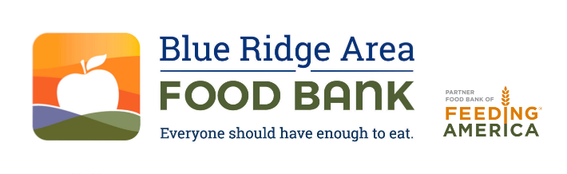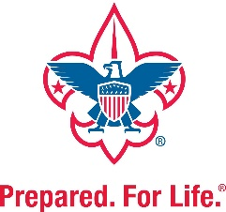

FOR IMMEDIATE RELEASE Media Contact: Les Sinclair
Phone: 434-962-5403.
Email: lsinclair@brafb.org
Scouting for Food Drives Community Impact:
More than 51,000 Meals in 2024
Verona, Va. (December 13, 2024) – The Blue Ridge Area Food Bank announces the results of the 2024 Scouting for Food campaign, which took place over the first two Saturdays in November. Thanks to the incredible efforts of local Scout Troops from the Shenandoah Area and Virginia Headwaters Councils, the initiative resulted in:
- A total impact of 51,081 meals for neighbors living with food insecurity through:
  - 39,636 pounds of food
  - $3,815 in donations
This year’s success builds upon an impressive legacy of service. Since the program began in 1985, Scouts have collectively contributed 982,803 pounds of food, along with cash donations, translating into about 828,540 meals for families across central and western Virginia. (Note: The Food Bank began formally tracking donations from this event in 2012.)
“We are deeply grateful to the Scouts, their families, and the community for their generosity and their dedication to helping people,” said Livia Marrs, volunteer and food drive manager at the Blue Ridge Area Food Bank. “The Scouting for Food drive is a testament to the power of collective action, helping us solve hunger, every day.”
On November 2, Scouts distributed door hangers in local neighborhoods, encouraging residents to prepare food donations. One week later, on November 9, the Scouts returned to collect these donations. The contributions were then delivered to the Food Bank and its network of community partners for distribution across the community.
Most-Needed Items
The Food Bank encourages donations of non-perishable, high-protein, low-sodium, low-sugar, and whole-grain items year-round to support its mission. Monetary gifts can also be made online at BRAFB.org.
About the Blue Ridge Area Food Bank
The Blue Ridge Area Food Bank is the largest hunger-relief organization serving Western and Central Virginia. Founded in 1981, the Food Bank serves 25 counties and 8 cities through distribution centers in Charlottesville, Lynchburg, Winchester, and its headquarters in Verona. Each month, the Food Bank supports an average of 148,200 guest visits, reaching record numbers of Virginians through a network of nearly 400 community partners—food pantries, soup kitchens, shelters, and program sites. As a partner food bank of Feeding America®, the nation’s largest hunger-relief organization, the Blue Ridge Area Food Bank pledges to continue innovating and adapting to secure, store, and distribute more food to more individuals, families, children, and seniors experiencing hunger. For more information, visit www.brafb.org.
About Scouting for Food
Scouting for Food is a national service initiative of the Boy Scouts of America. Under the slogan “Do a Good Turn Daily,” Scouts collect food to address hunger and support healthier communities. Participating Scouts earn recognition for their efforts, contributing to a legacy of service that exemplifies the spirit of their organization.

###

