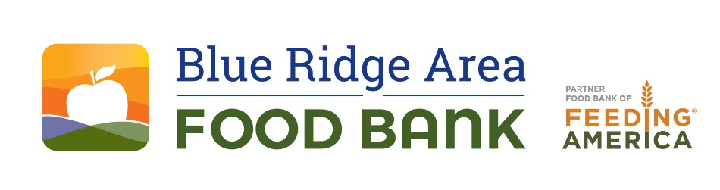

FOR IMMEDIATE RELEASE

Local Students Unite for Annual School Food Drive
to Support Blue Ridge Area Food Bank
Students and organizations join forces to collect food and restock the Food Bank’s shelves.

VERONA, Va. (February 27, 2025) – On Monday, March 3, the Blue Ridge Area Food Bank and 31 local schools and organizations will launch the annual School Food Drive. This year, the drive will include not only the greater Charlottesville area but will also extend into the Shenandoah Valley for the first time. Now in its 14th year, the drive will run from March 3 to March 21. All food collected during the drive will be donated to the Blue Ridge Area Food Bank and its food pantry partners in the area. This year's event also includes a fundraising component.

The annual drive will boost food supplies as donations typically decrease during this time of year. The food collected will help support local families who need it. The Food Bank and its 217 area partners—including soup kitchens, shelters, nonprofits, and food pantries—serve more than 68,000 individuals and families living with hunger each month.

Local students Lily Stendig of Albemarle High School and Sofia Smith from Tandem Friends School are leading this year's efforts in the schools. They aspire to build on the success of last year's drive, which helped provide more than 5,000 meals.

"The School Food Drive shows what the community can do when it comes together," Stendig said. "Young people throughout the area will demonstrate a real impact from our collective efforts."

Smith notes, "We are so proud to be part of the solution to food insecurity in our area. This food drive shows how students across the region can unite to make things better now and for tomorrow."

Participating schools for the 2025 drive include:

- Agnor Elementary School  - Albemarle High School  - Albemarle Montessori  - Bessie Weller Elementary  - Brownsville Elementary School  - Buffalo Gap High School  - Buffalo Gap Middle School  - Charlottesville Waldorf School  - Churchville Elementary School  - Covenant School (Lower School)  - Covenant School (Upper School)  - Crozet Elementary School  - Grace Christian School  - Greenbrier Elementary School  - Henley Middle School  - J. Frank Hillyard Middle School | - Johnson Elementary School  - Journey Middle School  - Lacey Spring Elementary School  - Monticello High School  - Murray Elementary School  - Red Hill Elementary School  - Renaissance School  - Staunton High School  - Staunton Montessori School  - Stone Robinson Elementary School  - Stony Point Elementary School  - Stuarts Draft Middle School  - Tandem School  - Trailblazer Elementary School  - William Perry Elementary School

"Costs of food, housing, and childcare continue to soar, and across our area, we are seeing more need—a lot more—so this drive could not come at a better time," said Livia Marrs, volunteer and food drive manager at the Food Bank. "It's inspiring to see young people stepping up to support the Food Bank. This expanded drive will help us collect a significant amount of food that will go directly back into the community."

Since the annual School Food Drive began in 2011, the participating schools and organizations have collected more than 101,000 pounds of food, or the equivalent of 83,925 meals, for neighbors living with hunger.

Each participating school or organization has large orange Food Bank barrels or other collection receptacles that the community can place non-perishable food items in. To learn more about how to support the 2025 School Food Drive, please visit: https://www.brafb.org/event/school-food-drive/.

***

FOR MORE INFORMATION CONTACT:
Les Sinclair, lsinclair@brafb.org, 434-962-5403

About the Blue Ridge Area Food Bank
The Blue Ridge Area Food Bank is the largest hunger-relief organization serving Western and Central Virginia. Founded in 1981, the Food Bank serves 25 counties and 8 cities through distribution centers in Charlottesville, Lynchburg, Winchester, and its headquarters in Verona. Each month, the Food Bank supports an average of 148,200 guest visits, reaching record numbers of Virginians through a network of nearly 400 community partners—food pantries, soup kitchens, shelters, and program sites. As a partner food bank of Feeding America®, the nation’s largest hunger-relief organization, the Blue Ridge Area Food Bank pledges to continue innovating and adapting to secure, store, and distribute more food to more individuals, families, children, and seniors experiencing hunger. For more information, visit www.brafb.org.

###

